Skin Graph-t

1/7/15

Very nice! Great work on the proofs.--RK

Technical Writer: Everyone

Engineer: Richard Yan

Reporter: Richard Yan

Conductor: Everyone

Morning Session: This morning Dr. Doug taught us how to find the chromatic polynomial of a graph. Doug also taught us about planarity and how K5 and K3,3 are the only two components that make a graph non-planar. We were also taught about trees and what different properties pertain to them; trees are connected and acyclic, and every edge is a bridge.

Afternoon Session: This afternoon went by smoothly. The material from the morning session were easily applied as always. There were a few problems on the homework that we did not get to, however, the ones that we did complete were straightforward and had minimal/resolvable issues.

1. No answer?--RK

2.

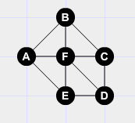

Nice example!--RK

3. Assume a graph is color critical and is disconnected. This would mean that there would be at least two vertices, we will call them O and P, that are not connected to each other but to different subgraphs. The subgraphs being disconnected from each other, they would have their own chromatic numbers, and as such the removal of any vertex in a set would not affect the chromatic number of any other set. This would mean that the graph is not color critical, because the chromatic number of the graph would not change as a result of the removal of certain vertices. Therefore a graph must be connected in order to be color critical. Nice argument! To make this precise, you should mention that there is one connected component of the graph G which has chromatic number equal to 𝜒(G). Removing a vertex from any of the other components won’t change the chromatic number, as you explained.--RK

4.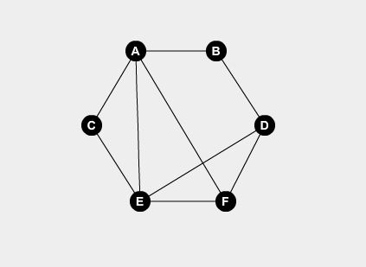

* This graph does not meet the requirements, examples, D and F are odd degrees, meaning the graph can not be eulerian. - Lizzy

5. The two un-necessary conditions were conditions one and condition four.

A hamiltonian/eulerian graph must be connected

A graph that contains K5 cannot have a chromatic number of 4 because K5 has a chromatic number of

Yes! Good explanations.--RK

6.

7.

8.

1. Assume there is a tree that has an edge that is not a bridge. Since the graph is a tree, no cycles can be present in the graph. A graph must have a cycle in order to be 2 connected or more. Since the edge isn’t a bridge, there must be a cycle in the graph. Therefore making it impossible for this graph to be a tree. ***Q.E.D.***

Ex. If lower right edge is not a bridge, there must be a cycle between the center vertex and the lower right, since we must assume that edge can be eliminated without disconnecting the graph.

1. Assume a tree, t, isn’t minimally acyclic. That means you can add an edge somewhere, without the graph becoming a cycle. However, all trees must have a size=order-1. Thus, to create a cycle, size must be greater than or equal to order. This means that t must be minimally acyclic, since it will always be one edge short of= order. Therefore, if one edge was added between two disconnected components, a cycle would be formed, violating the assumption. ***Q.E.D.***
2. A graph, G, is a non bipartite tree. This means it can’t be partitioned into two independent sets. However, since all of G’s edges must be bridges, and it is acyclic, it must be possible to split a vertex and it’s neighboring vertices’ neighbors into the same independent set, mutatis mutandis, without them ever sharing an edge, due to being acyclical. Thus, G is bipartite. ***Q.E.D.***

* Fantastic!!! Good job with these proofs! Your work has really improved. - Lizzy